**CARMA USER GUIDE**

1. **Objective**

This guide describes the PC configuration steps necessary to install and run the CARMA platform. The steps below match what the development team performed on their own PCs and some configuration may be different for other users.

1. **PC Configuration**

CARMA requires a Linux PC capable of running ROS Kinetic and ROS Java along with other software packages described below. The preferred OS is Ubuntu 16.04. Additionally, some cooperative vehicle systems use GPS synched timestamps, so a GPS based NTP server is highly encouraged.

**2.1** **Major Software Installations**

* OS
  + Ubuntu 16.04.2 LTS (Xenial Xerus)
    - The most recent version of Ubuntu directly supported by ROS Kinetic and the most recent Long Term Support version of Ubuntu
    - Size: 4.7GB
    - Installed from downloaded ISO
      * <https://www.ubuntu.com/download/desktop>
    - Installed all automatic updates after default installation. This should leave the pc at Ubuntu 16.04.6
* Software and Dependencies
  + ROS Kinetic Kame
    - The most recent version of ROS supported by ROS Java.
    - Size: ~4GB
    - Desktop-Full Install version follow instructions exactly
      * <http://wiki.ros.org/kinetic/Installation/Ubuntu>
  + ROS Java
    - A Java implementation of ROS which is currently updated to support ROS Kinetic
    - Size: ~1MB (This is the source size. Installation and deps will add overhead)
    - Installed using Deb Installation process
      * <http://wiki.ros.org/rosjava/Tutorials/kinetic/Deb%20Installation>
  + ROS Cpp
    - A Cpp implementation of ROS which is currently updated to support ROS Kinetic
    - Size: ~1MB (This is the source size. Installation and deps will add overhead)
    - Installed using Deb Installation process
      * <http://wiki.ros.org/roscpp>
  + A web interface system for ROS
    - Installed using installation directions at
      * <http://wiki.ros.org/rosbridge_suite>
      * Also see the Installing Apache and ROS Bridge section below
  + Apache Web Server
    - A web server to connect with the tablet
    - See install instructions in the Installing Apache and ROS Bridge section below.

**2.2** **Install CAN messages**

sudo apt-get install ros-kinetic-can-msgs

**2.3** **Install PHP**

sudo apt-add-repository ppa:ondrej/php

sudo apt-get update

sudo apt-get install php7.0

**2.4** **Install Socket CAN ROS Interface**

sudo apt-get install ros-kinetic-socketcan-bridge

**2.5** **Install Apache and ROS Bridge**

* Open a new terminal window
* Type “ifconfig” to get internal IP.

ens16 Link encap:Ethernet HWaddr 00:60:e0:56:1c:17

inet addr:192.168.88.107 Bcast:192.168.88.255 Mask:255.255.255.0

inet6 addr: fe80::4ada:4e87:d890:6157/64 Scope:Link

UP BROADCAST RUNNING MULTICAST MTU:1500 Metric:1

RX packets:11089 errors:0 dropped:0 overruns:0 frame:0

TX packets:6030 errors:0 dropped:0 overruns:0 carrier:0

collisions:0 txqueuelen:1000

RX bytes:10317123 (10.3 MB) TX bytes:944706 (944.7 KB)

* Type “sudo apt-get update” to get latest packages.
* Type “sudo apt-get install ros-kinetic-rosbridge-suite” to install rosbridge_suite.
* Type “source /opt/ros/kinetic/setup.bash” and “roslaunch rosbridge_server rosbridge_websocket.launch” to test installation.
* Type “sudo apt-get install apache2” to install Apache.
* Type “sudo apache2ctl configtest”.
  + If you receive a warning when checking your Apache configuration for syntax errors, type “sudo gedit /etc/apache2/apache2.conf”. Inside, at the bottom of the file, add a the server's public IP address:
  + Type “sudo apache2ctl configtest” to check again. You should see “Syntax OK”.
  + Type “sudo systemctl restart apache2” to restart Apache to implement the changes.
* To adjust the Firewall to Allow Web Traffic, SSH and RosBridge websockets:
  + Type “sudo ufw app list” to list applications available.

Available applications:

Apache

Apache Full

Apache Secure

CUPS

OpenSSH

* + Type “sudo ufw status” to check if enabled.
    - If “Status: inactive”, type “sudo ufw enable” to enable firewall if desired.
  + Type the following (not needed if ufw is disabled)
    - sudo ufw allow 'Apache Full'
    - sudo ufw allow 'OpenSSH'
    - sudo ufw allow 80 (http)
    - sudo ufw allow 443 (ssl)
    - sudo ufw allow 9090 (rosbridge)
    - sudo ufw allow 5900 (VNC)
    - sudo ufw allow 11311 (local ros communications)
  + Disabling UFW (OPTIONAL)
    - If the firewall is presenting continued issues UFW can be disabled with the “sudo ufw disable” command. This should be done with caution as it makes the PC more vulnerable by disabling the internal firewall.
  + Type “sudo ufw status verbose” to check configuration:

Status: active

Logging: on (low)

Default: deny (incoming), allow (outgoing), disabled (routed)

New profiles: skip

To Action From

-- ------ ----

80,443/tcp (Apache Full) ALLOW IN Anywhere

22/tcp (OpenSSH) ALLOW IN Anywhere

80 ALLOW IN Anywhere

443 ALLOW IN Anywhere

9090 ALLOW IN Anywhere

5900 ALLOW IN Anywhere

80,443/tcp (Apache Full (v6)) ALLOW IN Anywhere (v6)

22/tcp (OpenSSH (v6)) ALLOW IN Anywhere (v6)

80 (v6) ALLOW IN Anywhere (v6)

443 (v6) ALLOW IN Anywhere (v6)

9090 (v6) ALLOW IN Anywhere (v6)

5900 (v6) ALLOW IN Anywhere (v6)

* + Type “sudo systemctl restart apache2” to restart Apache.
  + Type “sudo systemctl status apache2” to check on Apache services.
* UPDATED FIREWALL to configure the new LOCAL IP’s port forwarding for port 2222, 80, 5900, and 9090.

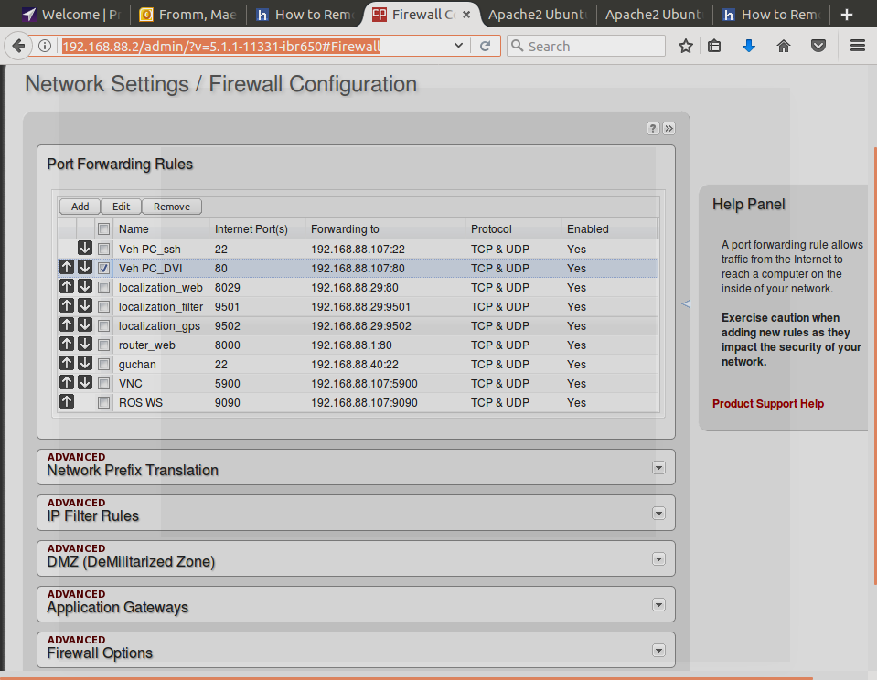

* Browse to the local and public IP to ensure the Apache is running and accessible.

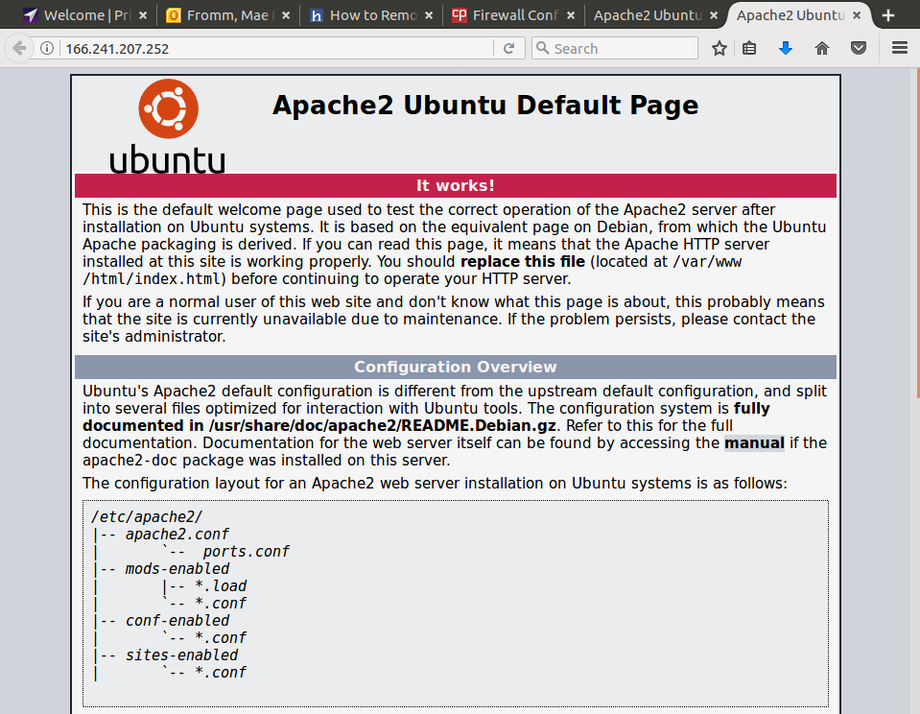

* Remove harmless inconsistent host warning from apache 2
  + sudo nano /etc/apache2/apache2.conf
  + # Add to bottom
  + ServerName <hostname>
  + # Restart PC